Installing kubeadm | Kubernetes
https://kubernetes.io/docs/setup/production-environment/tools/kubeadm/install-kubeadm/

https://kubernetes.io/docs/setup/production-environment/tools/kubeadm/create-cluster-kubeadm/

Steps to Install Kubernetes on Ubuntu 20
Create 3 Ubuntu Pro 20.04 LTS linux servers with m5.large( min 3 to 8 gb)

Ubuntu Pro 20.04 LTS

ami-00ca19b9fb851ec1b

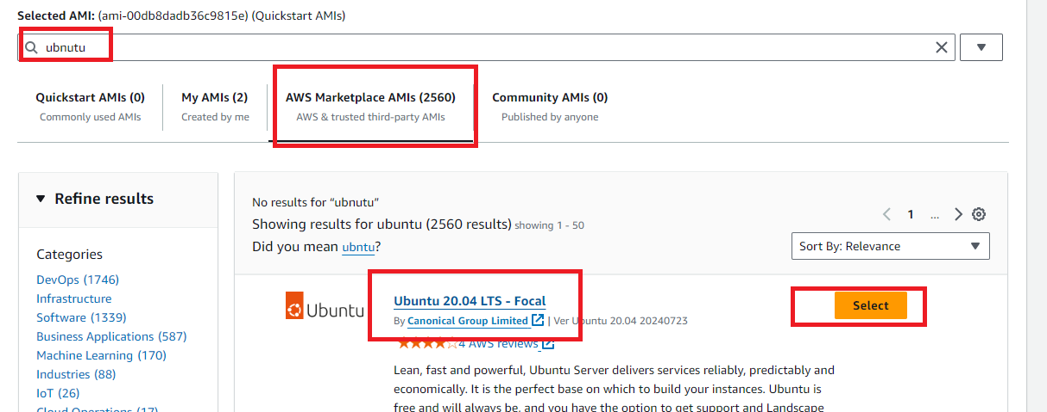

Set up Docker
ON 3 servers( on master and nodes)
- Create 3 aws ec2 instance with ubuntu 20 and m5.large
- sudo apt-get update
- sudo apt-get install docker.io -y
- sudo apt install -y containerd
- sudo mkdir -p /etc/containerd
- containerd config default | sudo tee /etc/containerd/config.toml
- sudo sed -i 's/SystemdCgroup = false/SystemdCgroup = true/' /etc/containerd/config.toml
- sudo systemctl restart containerd
- sudo systemctl enable containerd
- sudo swapoff -a
- sudo sed -i '/swap/d' /etc/fstab

Install Kubernetes
ON 3 servers( on master and nodes)
- sudo apt-get update
- sudo apt-get install -y apt-transport-https ca-certificates curl gpg

- sudo mkdir -p -m 755 /etc/apt/keyrings

- curl -fsSL https://pkgs.k8s.io/core:/stable:/v1.29/deb/Release.key | sudo gpg --dearmor -o /etc/apt/keyrings/kubernetes-apt-keyring.gpg

- echo 'deb [signed-by=/etc/apt/keyrings/kubernetes-apt-keyring.gpg] https://pkgs.k8s.io/core:/stable:/v1.29/deb/ /' | sudo tee /etc/apt/sources.list.d/kubernetes.list

- sudo apt-get update

- sudo apt-get install -y kubelet kubeadm kubectl

- sudo apt-mark hold kubelet kubeadm kubectl

- sudo systemctl enable --now kubelet

ON Master only:
15) sudo kubeadm init --pod-network-cidr=10.244.0.0/16
- mkdir -p $HOME/.kube
- sudo cp -i /etc/kubernetes/admin.conf $HOME/.kube/config
- sudo chown $(id -u):$(id -g) $HOME/.kube/config
- sudo kubectl apply -f https://raw.githubusercontent.com/coreos/flannel/master/Documentation/kube-flannel.yml

ON All NODES:

- kubeadm join 172.31.43.144:6443 --token 3pn3hh.gjylv106ucct2ryq \
--discovery-token-ca-cert-hash sha256:a91e64e0cb00c6d12c93a742b5666661c56cffdc7250002c32a21fb678187702

ON Master:
- kubectl get nodes
- kubectl get pods

Git use?

- Create github account and login
- Create a token(password)
- Install git on your laptop
- Create a remote remote repo
- Open terminal on VC and execute below commands
(only ones)
echo "# myK8s_Ds_8PM_03nov25" >> README.md
git init
git add README.md
git commit -m "first commit"
git config --global user.name "YourUsername"
git config --global user.email "YourEmail"
git commit -m "first commit"
git branch -M main
git remote add origin https://github.com/maha4dsvc/myK8s_Ds_8PM_03nov25.git
git push -u origin main
(username/password/token)

On k8s monster (only ones)
# git clone https://github.com/maha4dsvc/myK8s_DS_6AM_27oct25.git
# cd myK8s_DS_6AM_27may25
# ls

- For every change,

On VSC
git add -A
git commit -m “comment”
git push

On master
# git pull

https://github.com/maha4dsvc/myK8s_DS_6AM_27oct25

Your Kubernetes control-plane has initialized successfully!

mkdir -p $HOME/.kube
sudo cp -i /etc/kubernetes/admin.conf $HOME/.kube/config
sudo chown $(id -u):$(id -g) $HOME/.kube/config

kubeadm join 172.31.36.48:6443 --token crk9xa.y1q7kk5pzmm1coe3 \
--discovery-token-ca-cert-hash sha256:4835c9ab6d7592f1f3ab74230d6a34c7407426821c0c4f04ba4195efae8ec1c9

Docker ECR Repo:

Search for Amazon ECR.

Select Private registry → Repositories

Click Create repository.

Enter the repository name: myjavaapp

Click Create repository.

Create a IAM admin user

# apt-get install awscli
# aws configure
Accesskey: xxxxxx
Screatkey: zzzzzz
Region : us-east-2
Formate: json

# aws ecr get-login-password --region us-east-2 | docker login --username AWS --password-stdin 992558785875.dkr.ecr.us-east-2.amazonaws.com

# docker build -t myjavaapp:1 .

# docker tag myjavaapp:1 992558785875.dkr.ecr.us-east-2.amazonaws.com/myjavaapp:1

# docker push 992558785875.dkr.ecr.us-east-2.amazonaws.com/myjavaapp:1

k8s ‘s Deployments : Deploy my java application (mahalogin) on containers by k8s deployment.

- Install openjdk17 and maven on ur laptop
- Clone java application from github
- Build the java source code(mvn clean install) and generate war file
- Create Dockerfile and Build docker image by using war file
- Docker push image into docker registry
- Write and execute the manifest files for deployment and services
- Roll update application. R1 to R2
- Roll back the release from R2 to R1

# kubectl create namespace production

# kubectl create secret docker-registry ecr-secret --docker-server=992558785875.dkr.ecr.us-east-2.amazonaws.com --docker-username=AWS --docker-password="$(aws ecr get-login-password --region us-east-2)" -n production

# kubectl get secret ecr-secret -n production
# kubectl get deploy -n production
# kubectl get rs -n production
# kubectl get pods -n production
# kubectl get svc -n production
# kubectl get ep -n production

# kubectl delete namespace production

